***Client Intake Form*** Date: ____________

Full Name: ______________________________ DoB: ____________ Address__________________________________________________

City, State, Zip Code: ______________________________________

Occupation: ______________________________________________ Day Phone#: ______________________________ E-mail Address: ______________________________

Emergency Contact Name and Phone: ______________________________________________________

How did you find me / Who can I thank? ___________________________________________________

Marital Status: ______________________ Spouse Name: ______________________________________

Spouse Email: _______________________________ Spouse Phone#: ____________________________

Can we send deals and information about Dragonfly Touch Massage to you and/or your partner? ______

{ } Me only - { } Partner only - { } Both – Which way do you prefer? { } Text message - { } E-mail - { } Mail

***Massage / Aesthetic History / Session Information:***

Have you ever received a Professional Massage? { } Yes - { } No – If yes, When?: ___________________

Have you ever had an Aesthetics procedure done before? { } Yes - { } No – If yes, When? _____________

Do you use any kind of Cosmetics? { } Yes - { } No – If yes, what type(s)? __________________________

Sun Exposure: { } Yes - { } No – Sunscreen? { } Yes - { } No

Do you smoke? { } Yes - { } No – How many cigarettes per day? _________________________________

Do you Drink Alcohol? { } Yes - { } No – How often? ___________________________________________

Bowl Movements: { } 1-2/Week - { } 3-4/Week - { } 1-2/Day - { } 3+/Day

Do you Exercise? { } Yes - { } No - Types and Frequency: _______________________________________

Sleep Quality: { } Good - { } Regular - { } Bad – How many hours/Night? __________________________

How much water do you drink? {oz/Day} ___________________________________________________

How is your appetite? { } Good - { } Regular - { } Bad – How many meals? _________________________

Do you use Contact Lenses? { } Yes - { } No

Are you pregnant or trying to become pregnant? { } Currently Pregnant - { } Trying - { } No

Have you had any previous Births? { } Yes - { } No – If so, How many? ______ When? ________________

Last Menstrual Cycle Start Date: __________________________________________________________

Do you take Contraceptives? { } Yes - { } No – If yes, Which one(s)? _______________________________

Are you currently under the care of a health care practitioner? { } Yes - { } No - If yes, specify purpose: _____________________________________________________________________________________

List current medications and purpose (Include Vitamins/Supplements): _____________________________

__________________________________________________________________________________________________________________________________________________________________________

***Previous Health History / Surgeries (Include year and treatment received)***

Injuries / Accidents / Illnesses still affecting you: ______________________________________________

Medical Surgeries: _____________________________________________________________________

Plastic Surgery { } Yes - { } No - Specify: ____________________________________________________

Do you have any Dental Implants? { } Yes - { } No – If yes, Specify: _______________________________

Please Specify Allergies, if any: ___________________________________________________________

Please mark any of the following that you now have or have had:

{ } Bone or joint disease { } Heart condition { } Skin Conditions

{ } Tendonitis / Bursitis { } Phlebitis / Varicose Veins { } Respiratory issues

{ } Arthritis / Gout { } Blood Clots { } Gastrointestinal

{ } Jaw pain (TMJ) { } High/ Low blood pressure { } Cancer

{ } Lupus { } Lymphedema { } Spinal Problems

{ } Hormone Disease { } Epilepsy/Convulsions { } Psychological

{ } Thrombosis / Embolism { } Other: (Specify) ____________________________________

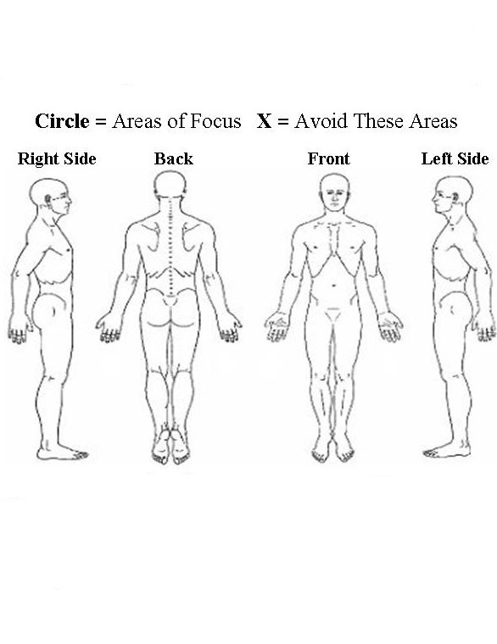***Treatment***

Please indicate in the picture: Circle the areas you are feeling Pain / Discomfort.

If you have specific needs of preferences, please list them:

_______________________________________

_______________________________________

_______________________________________

Are there any areas you would prefer to avoid?

_______________________________________

_______________________________________

Do you have a music preference? ___________

_______________________________________

What kind of pressure do you like?

Soft 1 2 3 4 5 6 7 8 9 10 Deep

What are your goals/expectations for this session?

_______________________________________

_______________________________________

_______________________________________

_______________________________________

Stress Level (None) 1 2 3 4 5 6 7 8 9 10 (Lots)

Anything else you would like your Therapist to know?

_____________________________________________________________________________________

_____________________________________________________________________________________

The following sometimes occurs during massage. They are normal responses to relaxation. Trust your body to express what it needs: The need to move or change position, sighing, yawning, change in breathing, stomach gurgling, emotional feelings and/or expression, movement of intestinal gas, energy shifts, falling asleep, memories.

***Client Agreement***

Please read the following information and sign below:

I understand that, although Massage Therapy can be very therapeutic, relaxing, and reduce muscular tension, it is not a substitute for medical examination, diagnosis, and treatment. I affirm that I was informed about risks, benefits, side effects, and general warnings related to the treatment(s) discussed. This is a therapeutic massage, and any sexual remarks or advances will terminate the session and I will be liable for payment of the full scheduled treatment. Being that massage should not be done under certain medical conditions, I affirm that I have answered all questions pertaining to medical conditions truthfully, and any false/omitted answers are not the responsibility of the professional or this institution.

All Services must be made and/or cancelled **12 hours** in advance. I understand that the therapist’s time is valuable, just as mine is, so **I agree that If I do not cancel my appointment *12 hours* before my scheduled treatment time, I am responsible for payment of the full treatment time, either with a non-refund or payment with my next treatment scheduled. This will also result in a pre-payment policy when scheduling my next 3 treatments.** Cancellation before 12 hours will not have any penalties.

{For Lymphatic Drainage Massage} Would you like a Before/After photo taken? { } Yes - { } No

I { } Do - { } Do Not - Authorize the use of my Before/After photos for Dragonfly Touch Social Media (My name and personal information will not be shared)



Signature: _______________________________________________________

Printed Name: ___________________________________________________

Date: _____________________________________________________